# The ultimate kit to build your own FLIP THE KNIFE GAME IN JUST SECONDS.

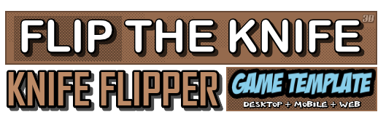

## **Are there any more features and versions planned?** We will be updating the asset from time to time, check the asset store for updates and to see version notes by clicking on the version notes (ex: v1.2 etc).

# REMEMBER IF YOU IMPORT THE PROJECT AND THE GRAVITY IS TOO HIGH, YOU WILL NEED TO CHANGE IT FROM THE **EDIT > PROJECT SETTINGS > PHYSICS** AND make the Y axis to **y: -3.5**

**INTRODUCTION**

**Thank you for buying this KIT, we really appreciate your support.**

**Welcome to Flip The Knife 3D - Knife Flipper Game Template documentation. This will tell you everything you need to know about the KIT and how to start building your own game easy in 1-2-3.**

This is a kit which contains prefabs, models, scripts in C# to create your own FLIP THE KNIFE or KNIFE FLIPPER game where you have flip the knife to get a high score each time you land correctly on the knife or just do other modes where you have to get the knife to somewhere else in order to advance to next level. This KIT provides you with scripts, models, animations, textures, sprites, prefabs and everything to start your own game, including two modes and some example projects with also a menu included. You can drag and drop the prefabs to create your own game or just edit the example scene to your needs.

**CREATE YOUR GAME WITH EASE**

This pack is simple, yet very powerful to create any type of game mode. You have two modes included in the package which are arcade where you have to get the knife on the blade to score or campaign mode where you have to move around furniture and stay on your sharp blade! (You need to always get on your sharp side to advance) and also including different weapons. This pack features a fully functional ready to use weapons which you can use with finger and swipe controls along with mouse button controls. This pack works for all platforms including mobile, web and desktop.

**What can I create with this?**

This KIT is mostly used for creating a KNIFE FLIPPER or FLIP THE KNIFE type game however with some changes you can create anything you want. This KIT includes the models and ready to use prefabs to just drag and drop so it is easy to create your own game. It also have features such as a fully functional weapons including 3 different weapons to choose from (you can also add your own) which can jump around and move onto furniture, customizable objects on which you can jump with physics and rigidbody that will work with swipe or mouse, different weapon types, fully function score feature, on screen home, reset and scene button, game win and end GUIs with score and more. You can create any type of knife flipper game and also create your own endless modes and get creative.

**Create a new empty project**

Create a new empty project, set defaults for 3D and Import this package into the NEW EMPTY PROJECT. **Please note:** Importing into an OLD Project may result in damaging your old project.

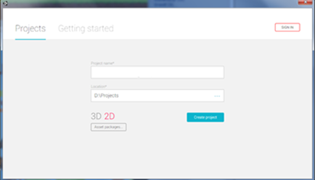

**Import Package to unity**

Import the package inside Unity using the import button, be sure that you select 3d and ALL are selected.



**Explanation of files**

**Animations folder**Animation folder contains all necessary animations. I advise not to touch these as they aren’t required unless you want to edit the animations.

**Audio folder**Audio folder contains all the KIT sounds and music including audio and sounds FX.

**GUIs folder**Contains the GUIs prefabs to use in game such as the button GUIs, gestures, End game screen and such.

**Materials folder**Contains the materials for all your models and prefabs.

**Models folder**Models folder contains the models example; such as furniture, trees, rocks, and nature models. Models cannot be confused with prefabs, as prefabs are ready to use part of the models with colliders and such and on the other hand the models contains nothing but just the mesh.

**Prefabs folder**Prefabs folder are different then the models folder because prefabs mostly are ready to use game objects and they come with collider, sometimes scripts and rigidbody so each prefab you drag into the scene it will have a collider which the player will hit and can drag and/or activate (Such as player, target objects which the player can flip the weapon on etc.) you can drag any prefab in the scene easy; if you drag flashlight for example, the player can just pick it up.

**\*Environment, Player Weapons, Props, Settings and Target Objects folder (Inside the Prefabs Folder)**The most important stuff are all located in the Prefabs folder. The environment folder contains ready to use ground and walls that you can put in your game. The Player Weapons folder contains the ready to use player weapons that are ready with colliders and such which you can use in the game. The Propswill be the objects that the player knife won’t be able to jump/flip on so they will not be tagged with TargetObjects and are mostly simple models which the weapon can’t flip on (frame, grass, vase etc.) and we only included only a sample of the props that you can use, however there are many more and you can create more from the models folder which all can be used as props and even target objects. The settings includes important prefabs to set up your game such as the background music and main cameras. The last folder is important for your game which is the Target Objects which will be the ones that you can jump/flip on which are tagged with the required tag TaergtObject. You can also create your own Target Objects by adding models and adding a collider to them and just tag them with the tag TargetObject tag.

**Scenes folder**Folder will contain the example scene and the main menu which you are free to modify.

**Scripts folder**Important folder which contains IMPORTANT scripts for your game.

**Textures folder**Textures used for your models, prefabs and such.

**explaining the two modes (+ you can create your own)**

The package includes two modes that you can start with to create your game. The modes are normal **‘arcade**’ mode where you have to flip the knife and bring it back to its position (on the sharp side) and a normal **‘campaign’** mode where you have to jump from furniture, objects and stuff to another and land on the same position (on the sharp side) till you reach the end level. These modes are included in the package and are easily to customize. You can also create your own modes if you want too, such as target practice or such, the possibilities are endless and you have everything to set up a knife flipper game, along with many customizations including buttons, camera that follows the target, knife types, GUIs, game end and game win screen and much more!

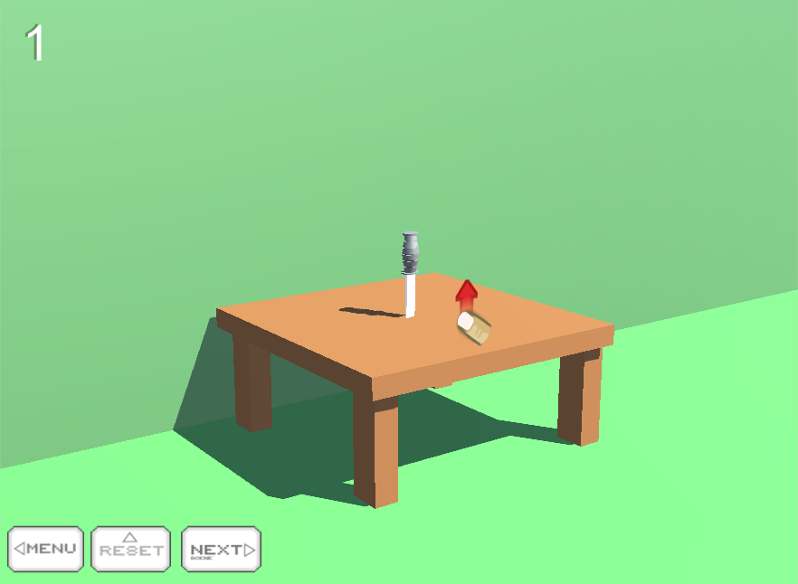

**Arcade mode** is simple, you have a weapon (knife or other of your choice) and you need to swipe or use the mouse button to flip and you have to try and bring it in the same position (on the sharp side) and each time you do that, you get a score.

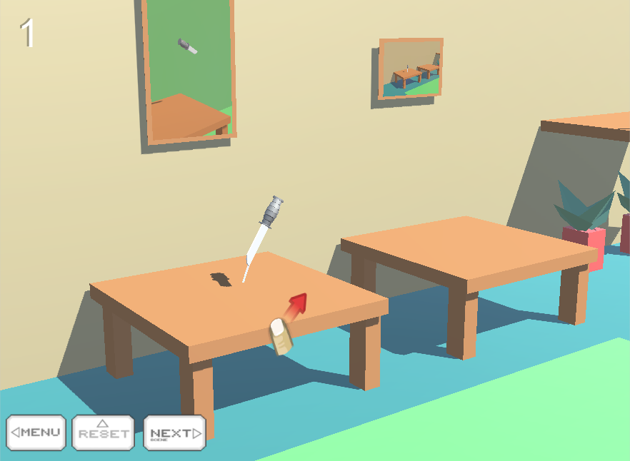

**Campaign mode** is more advanced from just standing in a table and flippin’ knifes. You have to jump from furniture, objects and stuff to another and land on the same position (on the sharp side) till you reach the end level, where then you get a game won screen and advance to the next level.

**better understanding and Explaining the diffrence between models, objects and props in the package.**

## **rECOMMENDED for a better understanding about models/props/target objects**

The package includes models, objects and props for your game. You can see them in the folder when you import the package. The models are the models of some of the objects and props, such as a chair, table etc. The models are not prefabs and they are not ready, so they are not tagged and do not come with colliders or such. This means if you drag and drop a model, table, chair, knife or something from the **Models folder** then you will need to add your own collider, tag and necessary stuff because they will be empty.

In the Prefabs folder however, you have two folders of interests. These are the **Target Objects** and the **Props**.

Prefabs comes ready to use that means with collider, sometimes tag and all the necessary stuff. The **Props** will be the objects that the player knife won’t be able to jump/flip on and the **Target Objects** will be the ones that you can jump/flip on because the **Props** are the objects that are not tagged with the required tag (‘TargetObject’) and the Target Objects are tagged with the required tag (‘TargetObject’). If you want you can still tag the props with the tag ‘TargetObject’ and then you can use them too, however most props will be small objects such as speakers, paintings and frames. The other Target Objects however, will be bigger stuff such as tables and stuff that the player can jump/flip on.

That means, if you want the player knife to flip on some object, all you have to do is add a box collider then tag it with the ‘TargetObject’ tag. Otherwise if the player flips on the object without the ‘TargetObject’ tag then the game will end, whenever you land correctly or not. If the object is not tagged with the required ‘TargetObject’ tag and if the player will hit any of these props, the game will end same as it does when you hit the ground or anything because the game will only continue if the player hits any object with the ‘TargetObject’ tag, which is used for the folder Target Objects.

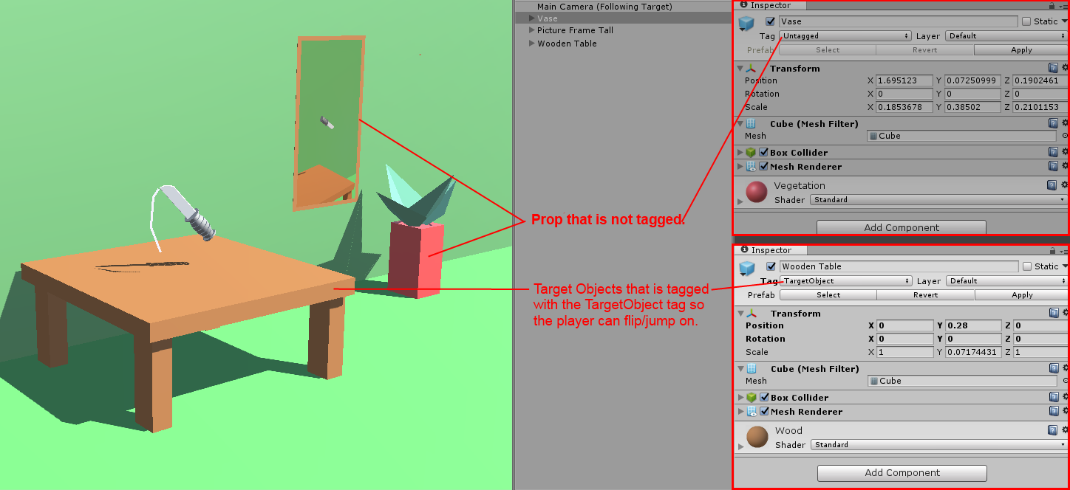

So, that means the Target Objects are the ones that are tagged and ready to use (you can also create your own) and the props are just basic objects that are not tagged so the player can’t jump/flip on them, unless you want to tag them.

**importing the package and changing the gravity.**

## **important to check the gravity of the scene as you can change it to your needs.**

Once when you import the package, you can see something that you may think it’s an error. When you start the scene and try to flip the weapon, you can see that the gravity is too much and the weapon is falling down or such, this is an ‘error’ because the gravity of new projects get changed so we need to change it back to its proper one, in case it gets changed again we added a script on each scene that makes your gravity better for your weapon.

In the settings folder there is a prefab called Change Scene Gravity Auto which automatically will change the gravity of each scene IF you put it onto your scene. What this script does is it will change the gravity of the scene when so it will be better, because if the gravity is too high then the weapon will not flip correctly, so you need to tweak it a bit and this prefab will do it automatically, So it is important to drag and drop the **Change Scene Gravity Auto prefab in your scene.**

If you want to do it manually and you don’t need to put the Change Scene Gravity Auto prefab in each and every scene, then you can change the project’s gravity by going in the Edit > Project Settings > Physics and there you will see Gravity in the Physics Manager. Change the gravity of **Y:** to **-3.5 so it will be just like in the screenshot below**.

The Y: gravity will now always be -3.5 and you no longer need to add the Change Scene Gravity Auto prefab in every scene. Your choice. Remember, that for the best results the gravity needs to be **X:** 0 **Y:** -3.5 **Z:** 0

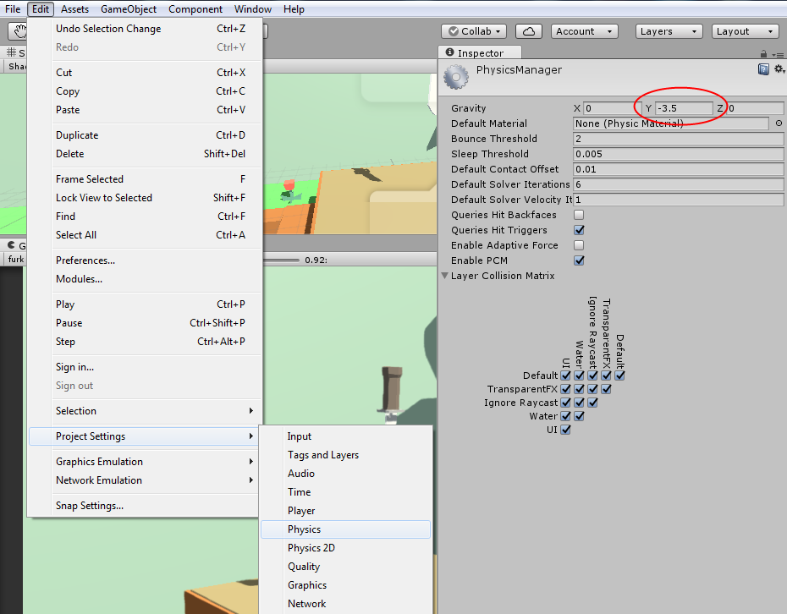

**Creating your own target objects**

You can also create your own target objects with your own models or such, let’s say you want to put a table that you modeled or you got into the scene and you want to start flipping weapons on it or such.

You can also use the models provided in the package to create your own Target Objects. Let’s show you an example on how you can achieve that. First off, import the model of your own or get the model you want into the scene and drag and drop it into the scene as a model it is. For this example, we will use a model provided with the package.

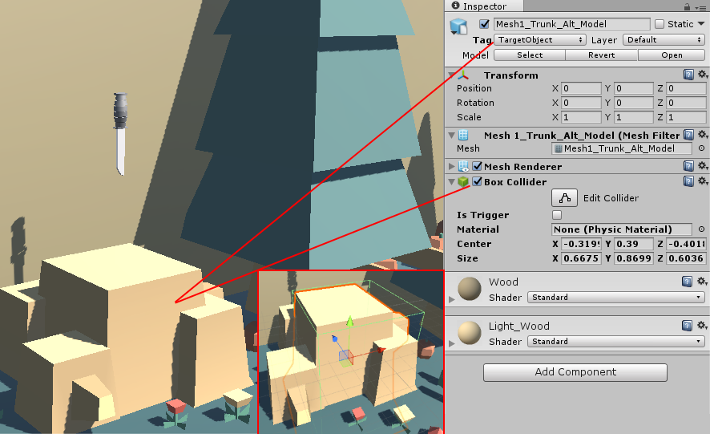

Once you added the model into the scene, go to component and add a box collider or a mesh collider (I will prefer a box collider, as mesh collider can sometimes not work as well) and then tag the object with the ‘TargetObject’ tag.

That’s basically it, all you need is to position the box collider perfectly to fit the model and you are done. Be sure that the tag is tagged with TargetObject and have a collider otherwise it will not work. Everything that the weapon can flip on will need to be tagged. If there is no tag then the game will end if it is touched, even if you land correctly on the knife.

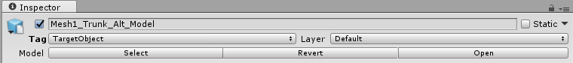

Remember, you can add any model you want but be sure to tag it with the required tag - **TargetObject**

**Quick see-throught of the prefabs**

Here you can see one of the scene included in the project (a scene like this can be made in minutes with this pack) which is explaining the prefabs in the scene so you will have an idea what to expect.

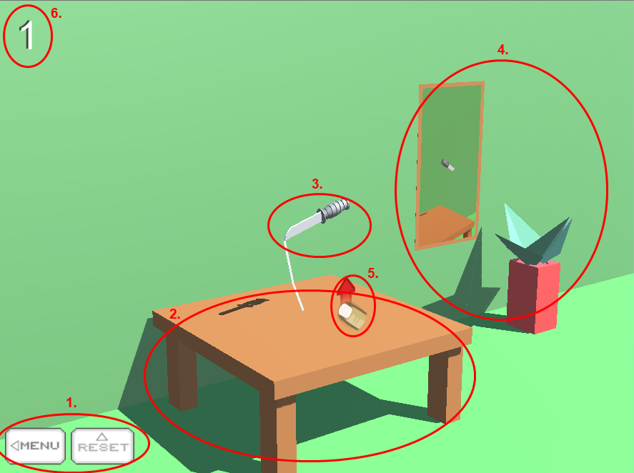

1. The menu buttons that can be changed to your needs and even customized. One button is the menu button which will take you back to the menu screen and the other is the reset button which will reset the scene.

2. A target object that the player can jump/flip on. The table is tagged with ‘TargetObject’ (All objects that the player can jump/flip on needs to be tagged with that and have a box collider) and have a box collider.

3. The player ready to use weapon which you will be using. It can also be changed to your needs and have many customizable options including speed, rotation and more!

4. Some props to make your game look cooler. These are props just like the others, however they are not tagged with the ‘TargetObject’ so that means the player cannot jump/flip on them, and even if he landed correctly it will display the game end screen.  
  
5. A simple GUI that shows you need to swipe up to flip the knife.

6. A score which can be customize that will show you how much score you got by flipping the knife correctly.

Everything you see can also be customized with color and stuff. You can also add your own Target Objects easily by just adding a box collider and a tag to your models. You can also create your own knife or such and use it easily, everything is customizable and you can create your own desktop or mobile game in just minutes!

**CREATING YOUR very FIRST GAME EASY (ARCADE MODE)**

This packages comes with all ready to use prefabs, so you can just drag and drop and only have to worry about creating the levels. This KIT will allow you to setup an easy arcade flip the knife game with all the basic features included. So, how easy is to create a game just like the one below? It just took me about 2 minutes to set it up.

**Let’s see step-by-step...**

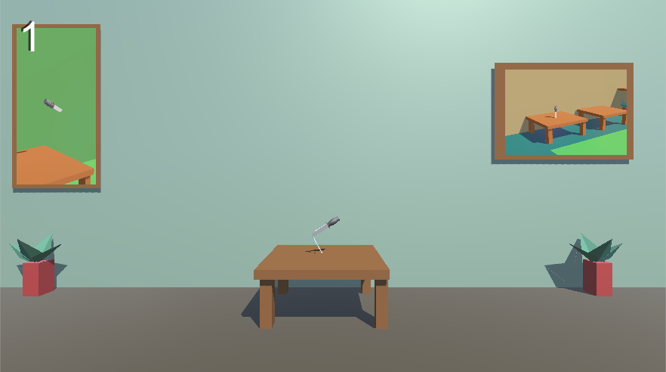

**Step 1:** Create a new scene and go to the folder where everything is located.

**Step 2:** Navigate to the Prefabs folder and drag and drop a weapon of your choiceinto the scene from the Player Knifes folder and leave it there for now. Now, you have your player knife which you can use in the scene but we need an object to flip it on. Let’s move and start adding some objects!

**Step 3:** Go to the environment folder in the prefabs folder and drag and drop a wall and a ground in the scene. Also in the prefab folder, navigate in the **Target Objects** folder, these are the objects that you can flip the player knife on and just go ahead and drag and drop an object there so we can place the player knife on it, for this example let’s drag and drop a wooden table into the scene.

**Step 4:** Now your scene is getting a little filled up! Go to the props folder and add some props to your scene making it look nicer. Position the player knife you dragged a while ago from Step 2 and make it on top of the target object, which is a wooden table.

If you done everything correctly, then you should have something like in the **screenshot above**.

Now as you can see it’s already finished, if you added the Main Camera already then your game is ready and if not, keep on reading on how to add the Main Camera or just change the one you have and position it to your needs. We suggest you use the Main Camera in the prefab as it have all the buttons and a nice fadeout added to it, but you can still use the one you got in the scene and just position that.

Now it’s time to add the main camera to make it look better (you can also just use the camera you have just like I did in the other screenshot and you can position it to your needs) into the scene.

**Step 4:** Navigate to the Settings folder and go ahead and drag and drop the **Main Camera of your choice** into the scene. (Both camera comes with the buttons, which you can click on and go back to menu or restart the scene and a screen fade) One is for following the Player and the other will just stay still. You can position the camera to your needs too. If you added the Main Camera (Following Target) then you need to drag and drop the Player knife into the Target of the Main Camera. For now, just drag and drop a normal camera; Main Camera (Normal) into the scene.

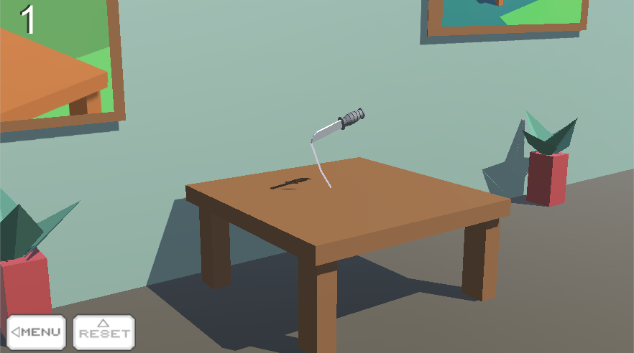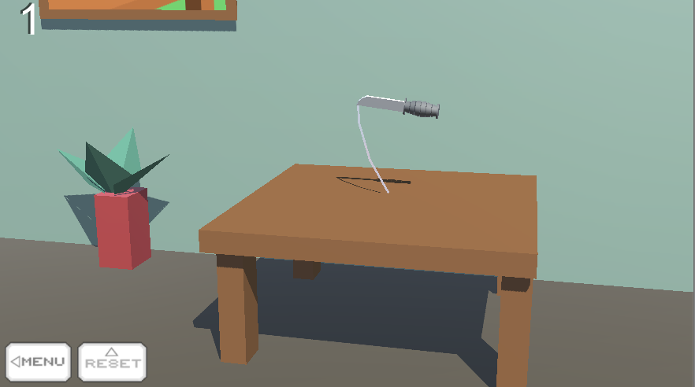

Once you add the Main Camera (Normal) into the scene you have to position it to your scene where there is your gameplay. Position it correctly to your needs (you may need to set it up and play around with it a little)

So you get the idea now, right? You can position the camera at any given position. Go ahead and add some more stuff and create your own game! You can use your mouse or fingers to swipe up and the Player weapon target will flip and you need to land it correctly in order to get a score, your score is displayed on the upper screen and everything can be customized from the Player weapon prefab on the PlayerFlipScript. Go ahead and play around with it a little!

**CREATING YOUR very FIRST GAME easy (campaign MODE)**

This packages comes with all ready to use prefabs, so you can just drag and drop and only have to worry about creating the levels. This KIT will allow you to setup an easy campaign flip the knife game with all the basic features included. So, how easy is to create a game just like the one below? It just took me about 3 minutes to set it up.

**Let’s see step-by-step...**

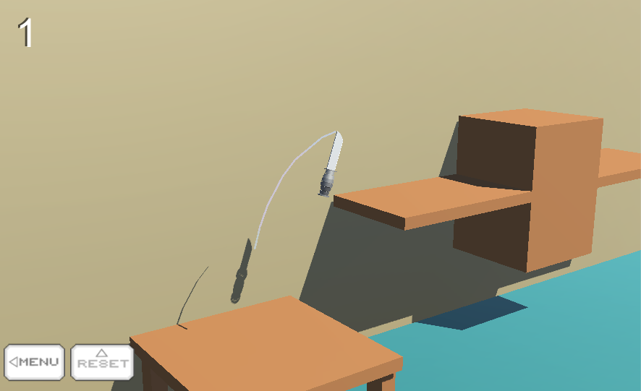

**Step 1:** Create a new scene and go to the folder where everything is located.

**Step 2:** Navigate to the Prefabs folder and drag and drop a weapon of your choiceinto the scene from the Player Knifes folder and leave it there for now. Now, you have your player knife which you can use in the scene but we need an object to flip it on. Let’s move and start adding some objects to flip on!

**Step 3:** Go to the environment folder in the prefabs folder and drag and drop a wall and a ground in the scene. Also in the prefab folder, navigate in the **Target Objects** folder, these are the objects that you can flip the player knife on and just go ahead and drag and drop an object there and here, maybe add a shelf and a table or two tables or something, for this example let’s drag and drop a wooden table and a shelf into the scene.

**Step 4:** Now, position the knife onto the table correctly so when it drops and the scene start it will land on the table or the target object of your choice. Then go to the Settings folder in the prefabs and drag and drop the Main Camera (Following Target) into the scene. Position it correctly and all you have to do is in the inspector of the camera you just put in the scene, go to the Camera Follow script and there is My Play.

Drag and drop the weapon you are using (Player Combat knife or so) into My Play so it can follow the target. If you done everything correctly, then you should have something like in the first **screenshot above**. You can also position the Main Camera when it’s following the target by changing the XYZ cords on My Pos above My Play.

As you can see, it is almost already done. All you have to do now is add a win game target object so when the weapon is flipped on it, it will display the win game screen and the game is won and the level is completed.

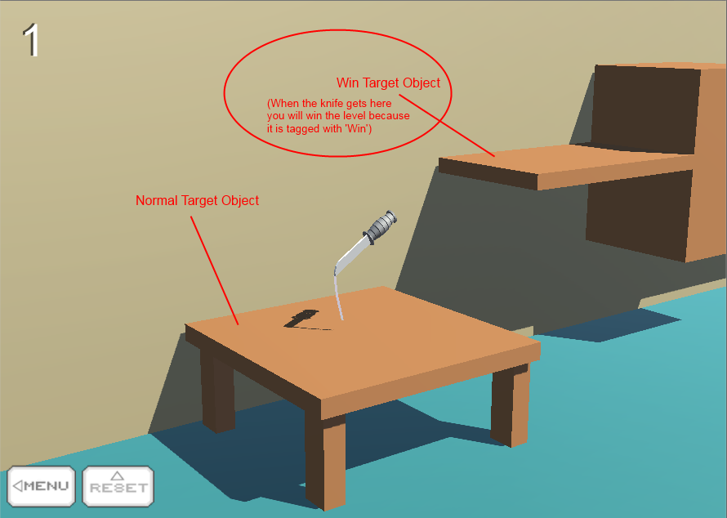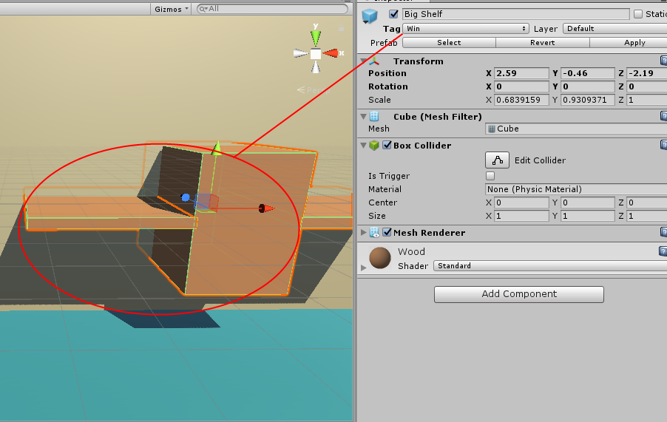

**Step 5:** Now, you have to do a target object so when the weapon gets flipped on it, the game is won. All you have to do is drag and drop another Target Object of your choice and change its tag from ‘Target Object’ to ‘Win’ and if the player weapon gets flipped on it, the win game screen will be displayed and level will be won!

**CREATING YOUR own weapons to flip**

You can add your own weapon model easy and start using it right away.

There is two ways you can approach this but it’s easier to just stick with one as you can just edit the prefab and add your own model. First, you need to understand that to have a weapon, you need; a collider for the weapon, a rigidbody with the Position Z and Rotation X and Y disabled, the PlayerFlipScript which is the main script to control everything, and a sphere collider which will be the important point where the weapon will be landing. If the sphere collider touches the Objects that are tagged with the ‘TargetObject’ then it will continue, otherwise the game end screen will be displayed. **We will start with the easy way on how to create your own weapon.**

**Step 1:** Let’s say you have your own model of a knife that you wish to use. First of all, drag and drop a player weapon into the scene, I will go ahead and use Player Combat Knife for this example.

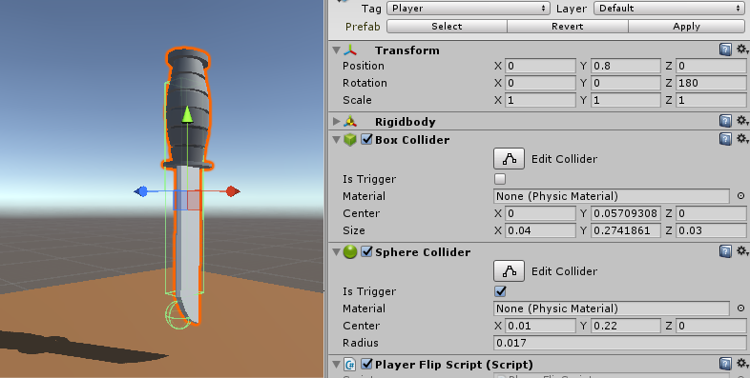

Now the model is a separate object from the weapon, so the box collider and a sphere collider is still on the target so even if you delete the mesh of the model because they are separate. Go ahead and remove the mesh.

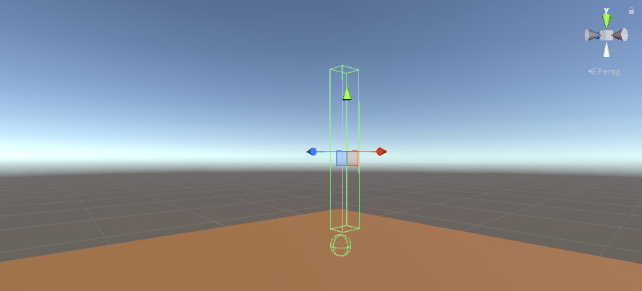

**Step 2:** Add your own model into the weapon, try to fit it in the box collider and sphere or just play around with the size of the box collider and radius of the sphere collider to fit your model. You can also move the sphere or box collider in the cords to fit your model’s needs.

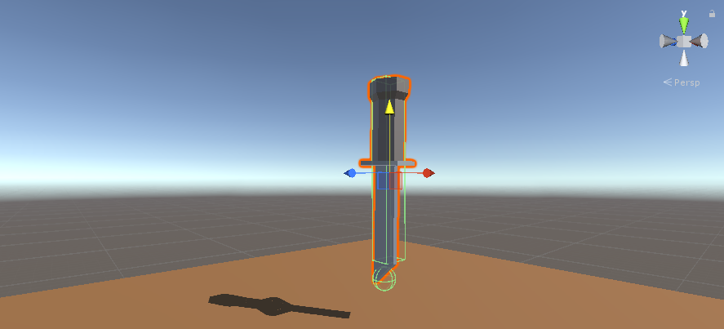

**Step 3:** Rotate and play around with the cords a little to fit your weapon, then test it out and see how it goes.

If you got it right, you may have something like this. Position and rotate your model to fit perfectly and you are good to go. Be sure that your model is set as child of the weapon so it will be always stick to it no matter what.

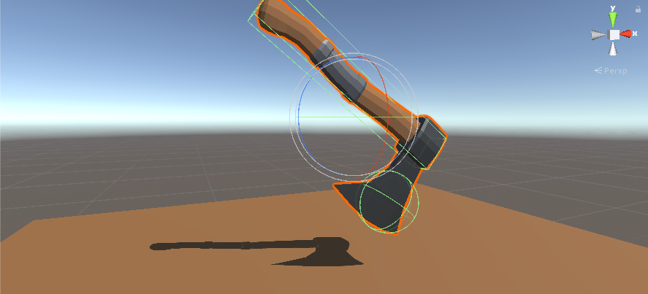

**You’re basically set, you can create any type of weapons of your choice, even axes!** All you have to do is play around a little with the colliders to get it right and you are good to go.

Apart from this, you can also add everything attached to your model instead but that will be harder, you will need to add a **box collider**, **sphere collider with trigger set to true**, an **audiosource** and the **PlayerFlipScript** on your model. You will need to set everything on the script and attach the rigidbody and such and then add a rigidbody to your model and freeze the Position cord Z and the Rotation cords X and Y. It will have the same results, but instead you will have your model set as main instead.

**EXPLANATION OF TAGs for PREFABS and game end sound**

Some prefabs will be tagged with the required tagged to work correctly, for example for the player target knife to continue when you hit the object you need to tag the object with the ‘TargetObject’ so when the knife sharp point hit the tag it will continue, other objects that are not tagged with anything will display the game end screen.

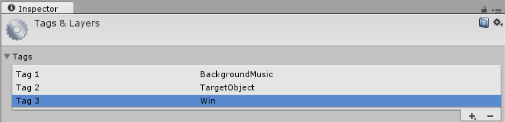

The **TargetObject** tag is the Target Object that the player weapon (knife of so) will land on so it needs to be always tagged with ‘TargetObject’.

The **BackgroundMusic** tag needs to be tagged with the Background Music (if you want to play a background music that is, so it can be destroyed when the game is won)

The **Win** tag needs to be tagged to any object that you wish to win the game after the player lands on it. Same like the TargetObject, however when the player weapon lands on it, it will display the win game screen instead of just continuing.

The **Player** tag needs to be tagged for the Player weapon target that you are using.

You can see the screenshot above (the first screenshot) to explain that each prefabs that need to collide or do an action needs to be tagged with the required tag. There are only 3 important tags to use. The TargetObject tag needs to be tagged for the objects that the weapon is being flipped on to work correctly, the Win tag needs to be tagged with an object that you want in order to win the game and the BackgroundMusic tag needs to be tagged in the background music prefab in order to stop playing the music when the game ends.

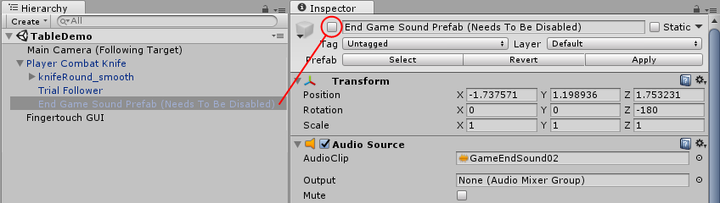

Also, remember that the end game sound prefab in the Player weapon target prefab needs to be disabled at start, otherwise it will just play automatically at the start of the game, and we want to only play it when the game ends so be sure it’s disabled at start, like in the screenshot below.

**Finishing your game and f.a.q**

If you finished all the steps then you may have a basic idea of all the features in the KIT. Please note that you can use your own sprites instead. Below we will do the F.A.Q and hopefully answer any questions you may have regards the KIT. If you are in doubt or stuck, be sure to check out the F.A.Q below and be free to use the example scenes provided to learn from them. The example scenes and prefabs are a great way to learn more. Enjoy your game making journey!

**1. Who is this KIT made for?**

This KIT is made for anyone who would like to experiment, learn and create a similar or any other game. This KIT will provide you the scripts you need to create it for both new users and who are willing to learn more.

**2. What is this KIT focused on?**

The main reason this KIT was release was for creating any type of knife flipper or flip the knife game.

**3. Can I add my own models instead of the KIT’s prefabs?**

You can add as many models and prefabs and such as you want.

**4. How do I change the background music?**

The background music is just an audio which can be changed from there in the Background Music Prefab.

**5. How do I change the game end sound?**

The game end sound is a prefab that is located and can be changed in the Player weapon target (knife or so) where you see **End Game Sound Prefab**. Open its children and there you will see ‘Game Over Sound Prefab (Needs To Be Disabled) and it can be changed from there. Be sure that it is always disabled at start! (The prefab, not the sound)

**6. Why is the game over screen displaying when I start the game?**

This can happen if the object that you are flipping (table, shelf or such) on is not tagged with the required tag. Be sure that the Target Object have a collider (box collider or so) and it is tagged with **TargetObject.**

**7. How do I change the game win or end GUIs and HUDs?**

Go to your player weapon target in your scene and in the inspector you should see the player flip script. There is the end game or win game full screen, score board and score style GUI which can be changed from there.

**8. How can I change the game win/end sounds?**

Unlike the game end sound, the game win sound is an audio not a prefab. You can change it still from the target player weapon in the player flip script in the inspector under WinGameSoundAudio. Just change the audio of your choice from there. The game end sound however, is a prefab instead of a audio and you need to open the player prefab and there is a End Game Sound Prefab and just change the audio from there to your needs.

**9. How can I change the speed of the target player weapon?**

You can change the speed by going in the inspector of the Player weapon target and in the script called Player flip script there is ‘Force speed’. You can change the speed from there, which is 5 by default.

**10. How do I change the main sphere collider when target player weapon hits on the target object?**

The collider is a sphere collider which can be changed in its inspector. You can play around with it and making it smaller or such, making the knife harder to stay a put. You can set it to your needs. It is the main important object In the pack as it detects the Target Object if the knife lands on it. Be sure that it is always upright and the other box collider is not blocking it off.

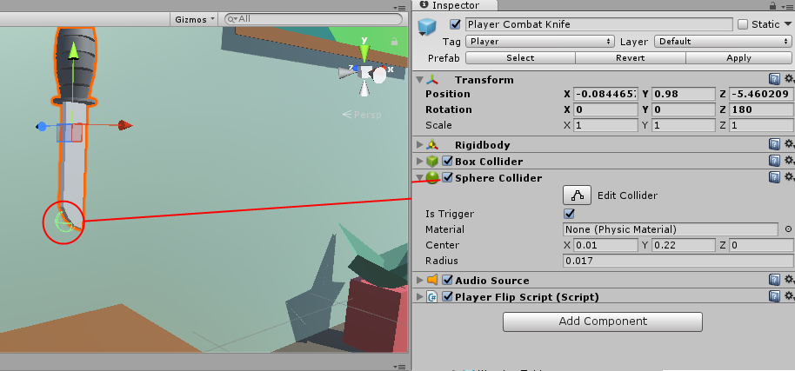

**11. How can I change the screen to a mobile view so I can see how it looks on mobile?**

Click on the little + sign at the bottom and a window will pop up. Then in label put anything you want and in the Width and Height do the following:

**Width: 480**

**Height: 800**

Also, leave the type to Fixed Resolution. This should display a kind of ‘Mobile view’.

**12. How can I add a win game screen when the Player weapon target** **gets on a specific target object?**

All you have to do is drag and drop a Target Object of your choice into the scene from the Target Objects folder and then change the tag to ‘Win’ instead of ‘Target Object’. Now when the player flips on this target object, it will display the win game screen along with a sound. You can customize it from the player weapon target inspector.

**13. How can I change the buttons on the main camera that are displayed?**

You can change them by going on the Main Camera prefab and in the OnScreenButtons script just assign a texture of your choice under the Home Button Texture and Restart Button Texture.

**14. My target object is tagged with Target Object, but I still get the game end screen instantly?**

This can occur if the sphere collider on the weapon is blocked off by the other box collider or so. Check the in the inspector and see if the sphere collider is blocked off by the other collider as it needs to be a little lower. Check this screenshot here.



If this happens, try to put the sphere lower than the box collider or just put another weapon from the Player Weapons folder into the scene and see if that works.

**15. Can I re-skin and do all the features with my own models?**

Yes you can. All you have to do is put the models in your scene and add the scripts, colliders and stuff that the prefabs are using with your own models and you are good to go.

**16. How do I change the score that is displayed?**

Go to your player weapon target in your scene and in the inspector you should see Score Style Normal and Score Style Shadow. You can change them to your needs from there.

**17. How do I change the screen fadeout that appears in the begging on the Main Camera prefab?**

In the inspector of the Main Camera, there is a script called ScreenFade. There you can choose which image you want to fade and how long till the fade last.

**18. When I lose and the game ends, it displays the error ‘Level Menu (1) couldn’t be loaded etc.”?**

You need to assign the menu to the build. Go to the build settings and add the Menu and scenes and then try again. Whenever the game ends it will take you back to the menu screen.

**19. How do I add the scripts and features to my own Main Camera?**

Go to the scripts folder and drag and drop the OnScreenButtons.js and ScreenFade.js, then you will have all the same features as the one in the prefab folder. You can also add the CameraFollow.js script as this will make the camera follow your target. You will need to change the XYZ cords and play around with it a little to set it up.

**20. Why when I advance to next level after I finish the game gets stuck or gets a white screen?**

You may need to add your levels to the build settings. Go to file and go to Build Settings and add the scene by pressing Add Open Scenes.

**21. Camera is too close, how do I change this?**

Go to your Main Camera and from there you can change the Field Of View. Change the size to your needs.

**22. My weapon/knife is not flipping?**

Check in the inspector and see if everything in there is missing. Be sure everything such as the End Game Screen, The End Game Sound Prefab, Rigidbody and such is all attached to its required positions.

**23. Can I add more modes to this, like target practice or something?**

Yes! A little bit of programming and you can add as much modes as you like. For example, you can also add a target practice mode and all you have to do is position the camera with a good angle and put the target and just tag it with ‘TargetObject’ or ‘Win’ if you want to win the game after the weapon hits the target and you can throw the knife to the target in order to win. The possibilities are endless on what you can create!

**23. How can I change the Main Camera (Following Target) to be closer and such?**

You will need to change the cords XYZ in the Main Camera (Following Target). Go to the Inspector of the camera and there you will see My Pos in the CameraFollow.js script. You can change them to your needs from there.

**24. My camera is NOT moving along with the weapon?**

You will need to attach the weapon that you are using with the Main Camera. To do this, go to the inspector of the camera and there you will see My Play and all you need to do is drag and drop the weapon you are using (Player Combat Knife or so) into the My Play and that should work.

**25. There are only few models as prefabs?**

These are only a sample of the 100s other models which are located in the models folder. You can drag and drop these models from the models folder into the scene and just use them on how you wish (target objects or just normal props models)

**25. How do I change the gravity of the scene? The weapon falls too quickly when I play it!**

You need to change the gravity of the scene by going in the Edit > Project Settings > Physics and there you will see Gravity in the Physics Manager. Change the Gravity **Y:** to **-3.5** and leave the others **0**. (X: 0 Y: -3.5 Z: 0)

**26. After or before I start the level, the lightning comes out weird or black/darker?**

This can be a weird thing that unity does with the lightning and it is not from the package error. You need to go to WINDOW > LIGHTNING > SETTINGS and scroll out to the bottom of the new window that pops up. At the Debug Settings there is an Auto Generate box and untick it making sure it is disabled. If the lightning is still weird, just press on the Generate Lightning box and it should work fine.

**27. The reflections are weird when I start the level?**

This is another weird thing that it does, not from the package. Go to the lightning settings again and where you see Intensity Multiplier under Environment Reflections just scroll it to zeroor change it to 0.

** We will update this F.A.Q with any questions you may have or ask us for other to see if it is not listed here. If you have any questions regarding this package or anything else, please don’t hesitate to contact us at **Steelkrill.com. \*\***

**Will this pack be updated and do you have any more planned features?**

This KIT is still young and new and needs to grow and we plan on updating this package. We are working on improving this KIT and if any of you have any suggestions or feedback please don’t hesitate to let me know. We will do our best to update the KIT frequently and even plan on adding loads more. If anyone have any inquires, if someone is missing or you have any questions or feedbacks please don’t hesitate to contact us.

Hope you enjoy your game making journey and I wish to thank you very much for all your support. Have a great and fantastic day everybody! If you need anything, do not hesitate to contact.



**Thank for your purchase and enjoy. Happy game making journey!**